Commercials

Site Reference Images



**Client Responsibilities \***

* Freight payment, at actuals
* Provision of electricity & scaffolding for installation
* Unloading and safety of material at site
* MS Fabrication work, if any

Material processing begins

10-12 weeks after color confirmation

1-2 weeks post site readiness confirmation

Confirmation for the same to be provided by client *

Shop Drawings to be

provided by us

To be followed by site revision

Installation Commencement

Site Readiness

Material Delivery

Color RAL Confirmation

Advance Receipt

Actual Site Measurement

Timelines

Payment Terms

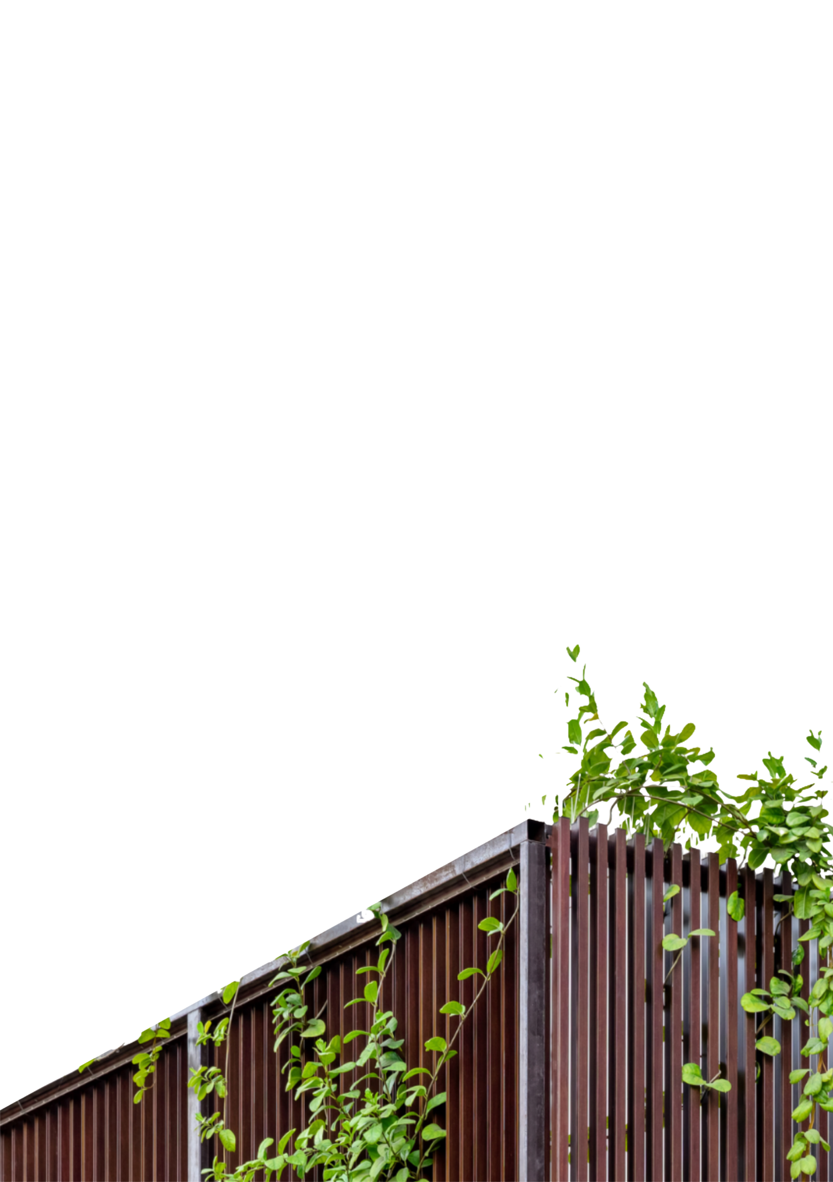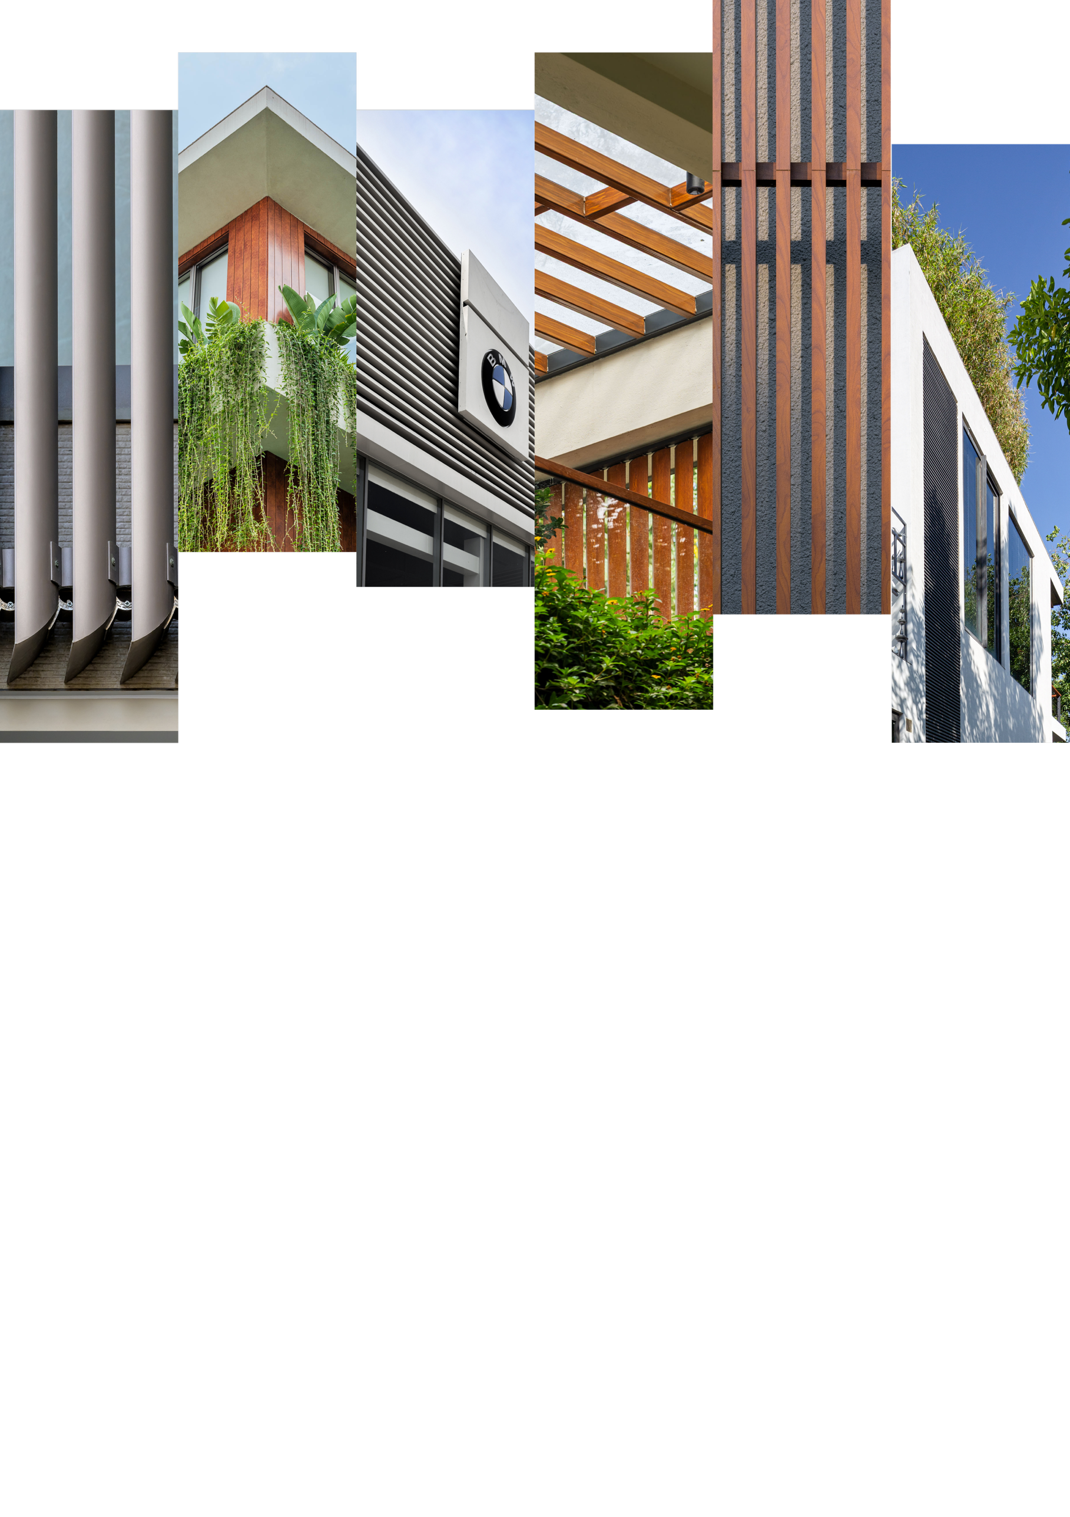]

«OfferRep»

Vibrant Technik

«OfferRepPhone»

**Bank Details**

|  |  |
| --- | --- |
| Account Name: | **Vibrant Technik** |
| Bank: | **HDFC Bank** |
| Branch: | **Bani Park, Jaipur** |
| A/C No.: | **03482320002112** |
| RTGS/NEFT IFSC: | **HDFC0001430** |
| Type of Account: | **Current** |
| GST Number: | **08ABXPG5266G1Z6** |
|  |  |
| Offer Valid Until: | «ExpiryMonth» «ExpiryDate», «ExpiryYear» |

I acknowledge and accept all terms and conditions outlined in this commercial proposal.

«FullName»

«CompanyName»

«Mobile»

**60%** advance,  
  
**30% + Full GST** against Proforma invoice before delivery of material to the site,  
  
**10%** balance after completion.

Get to

know us

From small beginnings,

We’ve come so far.

With each step forward,

we’ve raised the bar!

At Vibrant Technik, we redefine architectural elevations with our aluminium alloy 6063 louvers, offering seamless customization through advanced automation.

The product stands, a quiet testament to both purpose and space, its essence whispers to the world around it. Driven by a passion for innovation and design, we’ve evolved alongside our clients, learning and improving with every project.

Our commitment to excellence ensures each solution fits, blending form and function in perfect bits.

world around it. Driven by a passion for innovation and design, we’ve evolved alongside our clients, learning and improving with every project.

Our commitment to excellence ensures each solution fits, blending form and function in perfect bits.

They trust us

For queries, please contact

«OfferRep»

«OfferRepEmail»

«OfferRepPhone»

Find all our offerings

on our website

Let’s turn this opportunity into

*a shared success.*